33 fallin the blanks below to snow how the author related to the rubber toy. [3m]

a) After the .  
fishmonger passed [-) hefeltthatshewasa aly  
ihe rubber toy io }  
the author |

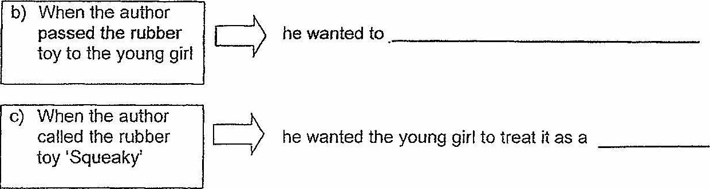

FND OF PAPER

ae